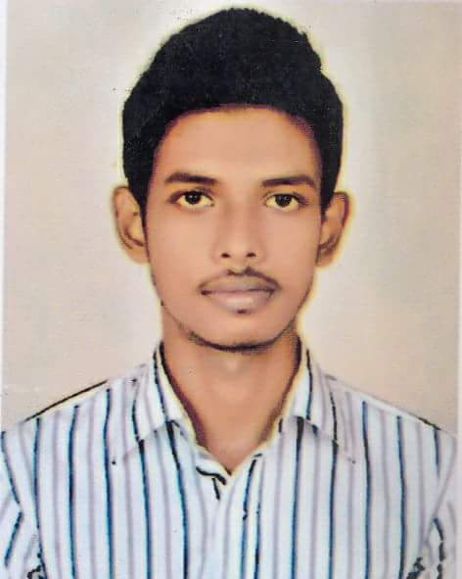

CURRICULUM VITAE

Of

PROSENJIT PAIK

## CONTACT ADDRESS:

Prosenjit Paik

New Bus Stand,Maijdee, Noakhali.

Mobile: +8801401-369837, +8801841-050145.

Email: [bslprosenjitpaik@gmail.com](mailto:bslprosenjitpaik@gmail.com)

## OBJECTIVE:

I prefer in doing job in any established and progressive organization with pride and prestige having in opportunity of the best use of latest technology in all areas. I feel enough independence to explore my professional vision and experience in doing job, will bright more and benefit of the organization.

**Which things make me different?**

* Hard working.
* Time maintaining.
* Accept any kind of Challenges.
* Regularity maintaining.

# ACADEMIC QUALIFICATION:

**BBA (Bachelor of Business Administration)**

* Institute : Govt.BM College, Barisal.
* Passing Year : 2019
* Board : National University
* Subject : Marketing
* Result : CGPA-2.81 (Out of 4.00)

**Higher Secondary School Certificate (H.S.C)**

* Institute : Amrita Lal Dey College, Barisal.
* Passing Year : 2014
* Board : Barisal
* Group: Business Studies
* Result : GPA-4.70 (Out of 5.00)

**Secondary School Certificate (S.S.C)**

* Institute : Barisal Zilla School, Barisal.
* Passing Year : 2012
* Board : Barisal
* Group: Business Studies
* Result : GPA-4.94 (Out of 5.00)

**COMMUNICATION SKILL:**

Reading, Speaking, Writing Proficiency in Bengali & English.

**COMPUTER TRANNING:**

MS Office Application, MS Excel, MS Access, E-Mail, Internet Browsing, Etc.

**Experience:**

***Working in Daraz Bangladesh Ltd. as Manager in Daraz Barisal Office from 19th July, 2017 to 31st March, 2018.

***Working in Jamuna Group as a Monitoring Officer in Barisal from 1st October, 2018 to 31st May, 2019.

***Working in Popular Group as a Customer Service Officer in Popular Diagnostic Centre Ltd. Dhanmondi & Noakhali Branch from 1st June, 2019 to still now.

**PERSONAL PROFILE:**

Name : Prosenjit Paik

Father’s Name : Ranjit Paik

Mother’s Name : Kanchan Mala

Date of Birth : 26th July, 1997

Sex : Male

Nationality : Bangladeshi (By birth)

Religion : Hindu

Marital Status : Unmarried

Blood Group : A+ (Positive)

Permanent Address : Vill: Ghurchakathi, Thana: Bauphal, Post: Dhulia,

Upazila: Patuakhali, Dist: Barisal.

**DECLARATION:**

I do hereby that all information is true and correct to the best of my knowledge.

**Signature**

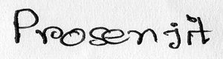

­ (Prosenjit Paik)

Date: 18/06/2021